Chapter 10 The nature of waves

Chapter Test Total marks 40

**Name:** ______________________________ **Class:** ____________ **Date:** ________________

Question 1 (1 mark per question)

A drummer beats his drum five times every two seconds. The frequency of the drumming is:

1. 0.67 Hz.
2. 2.5 Hz.
3. 1.67 Hz.
4. 3 Hz.

Question 2

According to wave theory, when two crests collide they:

1. pass through each other with no visible effect.
2. cancel out each other leaving an area of no disturbance.
3. superimpose on one another to momentarily create a larger waveform.
4. reflect as if each collided with a solid wall.

Question 3

The frequency of light of wavelength 560 nm travelling at 2.98 x 108 m s–1 is:

1. 5.36 x 1014
2. 5.32 x 1014
3. 5.36 x 10–4
4. 5.32 x 10–4

Question 4

Which of the following do all waves transfer from one point to another?

1. matter and information
2. energy and matter
3. energy
4. information and energy

Question 5

What is the name given to the point of maximum positive displacement along a wave?

1. Rarefaction
2. Compression
3. Trough
4. Crest

Section B

Question 1

1. Sketch a displacement versus distance graph representing the movement of the particles with the following properties: Wavelength = 0.2 m, amplitude = 0.05 m. (2 marks)
2. Use a dot to indicate the location of the particle on the graph at a distance of 0.1 m from the origin. If the wave is travelling to the right, use an arrow to indicate the direction (up or down) this particle is moving at the time shown. (1 mark)

Question 2

Explain the difference between a longitudinal wave and a transverse wave. Give an   
example of each. (4 marks)

Question 3

Humans are currently investigating the feasibility of living on Mars. Mars is 1.5 times the distance from the sun compared to Earth. If Earth receives approximately 1370 Wm-2 of   
energy from the Sun how much does the surface of Mars receive? (2 marks)

Question 4

With reference to waves, define the term ‘destructive interference’. Use an example to support your definition. (2 marks)

Question 5

1. Determine the period of the wave responsible for the motion of the particle depicted on the graph below. (1 mark)



1. Calculate the speed of the wave if the wave moves 2 m in the time for one period. (1 mark)

Question 6

Explain why, using your knowledge of sound waves, you can hear an echo when you shout across a deep river valley and how air transmits sound. (2 marks)

Question 7

Your friend wants to install a mirror on the wall in their house. You are told that when they are standing their eyes are 1.5 m directly above their toes. Use the law of reflection to determine how far the bottom of the mirror has to be off the ground so your friend can see their shoes in the mirror. (2 marks)

Question 8

A wave was observed crossing the boundary between two mediums. The wave travelled the same distance in in each medium but took more time to travel this distance in the second medium compared to the first.

Compare the properties of the wave before and after it crossed the boundary between the two mediums. (2 marks)

Question 9

A friend sits stationary on a swing and asks you to push them. Explain how the concept of resonance relates to pushing your friend so their height of swing increases over time. (2 marks)

Question 10

Outline the conditions that must be met for a standing wave to be produced. (3 marks)

Question 11

Two pulses on a string approach each other as shown below.



1. On the grid below, draw in one colour the positions of the two individual pulses 2 seconds after their positions shown in the diagram above. (2 marks)

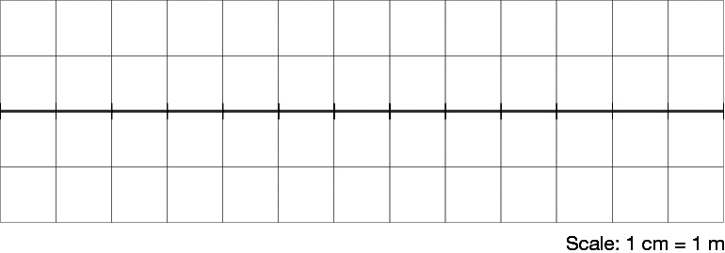

1. Then draw in another colour the superposition of the two pulses at this time. (1 mark)

Question 12

A guitar string is held stationary at a point along the neck of the guitar by pressing a finger on it. This finger is 0.5 m from the fixed end of the string and the string is plucked somewhere along this 0.5 m.

1. Describe where the nodes and antinodes of the first harmonic exist on this 0.5 m of string.  
    (1 mark)
2. Calculate the wavelength of the first harmonic standing wave produced in the string.

(1 mark)

Question 13

A simulator of the human head is used to determine the efficiency of hearing aids. The process involves a set frequency sound being produced from a speaker at one side of the simulator as shown in the diagram. Hearing aid A is closest to the speaker and a display of its reception is given.

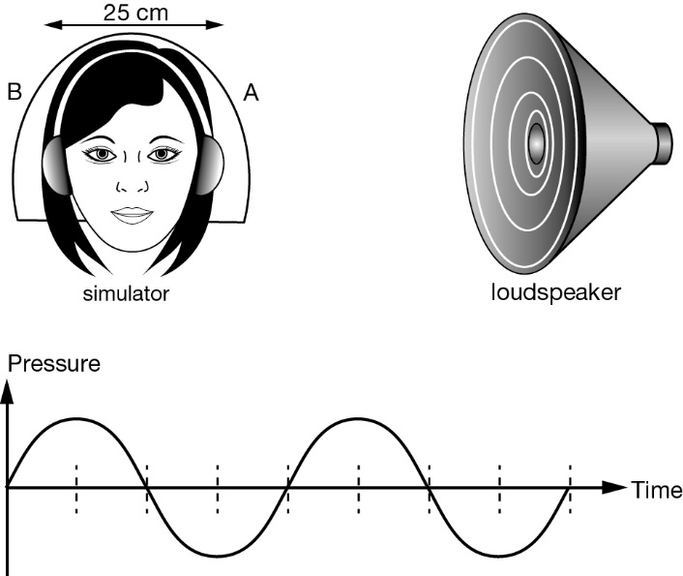

1. On the same axes draw the display as it will appear one-quarter of a cycle later. (2 marks)

Hearing aid B is 25 cm further from the speaker than hearing aid A. The graph below indicates the reception from both hearing aids at the same time.

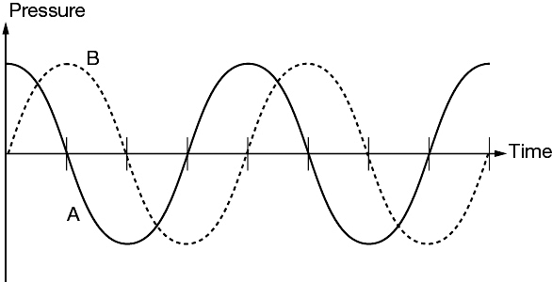

1. What is the wavelength of the sound? (2 marks)
2. Given the speed of sound is 340 m s–1, determine the frequency of the sound. (2 marks)